APIM Service code generator

digital Azure COE

APIM Service Code Generator input form and APIM policies Test cases

# web interface

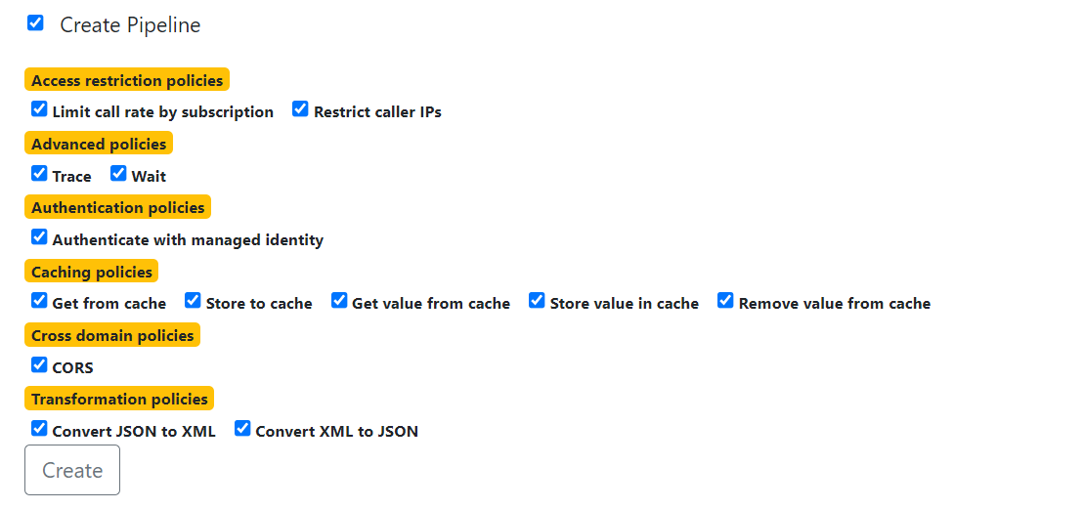

|  |  |
| --- | --- |
| Convert JSON to XML or XML to JSON - should not be represented with checkboxes. | Both cannot be applied at the same time hence they should be grouped with radio buttons. |
| Basic & Advance policies are mixed | Basic & Advance policies must be segregated by different boxes. |
| Caching Policies -> Store to Cache is presented as one of the caching policy. | **Store to cache** should allow the User if he wants to apply any caching policies. The user should be allowed to choose caching policies only if **Store to cache** is selected. Else all of the caching policies should be disabled. |
| Missing policies | Few policies are missing Ex: Certification |
| Validation | Field Level validations are missing Ex: Pilot API name must contain alpha numeric, dashes and up to 60 characters length. |
| User input on the screen shouldn’t change after submit | User input must be same before and after form submission |
| In Progress alert is missing on submission | In progress icon should be displayed |

# inbound policies summary

|  |  |  |
| --- | --- | --- |
| Policy | **Test case** | **Screenshot# for evidence** |
| Set-header | Check if input headers are set successfully |  |
| Rate limit by Key | API usage rate is driven by no. of calls, renewal period & key |  |
| Quota by key | Check if bandwidth quota and key is respected in API usage. |  |
| IP Filter | Check if IP Filter policy is set with IPS provided on the web interface. |  |
| Cache store value | Check if the key/value pair is stored in Cache |  |
| Cache remove | Check if the key/value pair is removed from cache |  |
| Cache expiration | Check if cache expiration works properly |  |
| Set-status | Error code “403” is set when the client provided certificate is invalid |  |

# inbound policies details

|  |  |  |  |
| --- | --- | --- | --- |
| Policy – IP Filter | **Expected** | **Actual** | **Pass/Fail** |
| User checks the Restrict Caller Ips check box | Application allows the user to input one or more caller IPs | No input box is displayed when Restrict Caller Ips checkbox is selected. |  |
| User access an API using an IP that is not in restricted IP list | User should be directed to Forbidden Error Page |  |  |
| User access an API using an IP that is in restricted IP list | User should able to access the API |  |  |

|  |  |  |  |
| --- | --- | --- | --- |
| Policy – Rate limit by Key  Rate: 20 per 90 secs  Subscription Id: <>  Increment Condition: Http status code 200 | **Expected Behavior** | **Actual Result** | **Pass/Fail** |
| Request to an API is made when the usage rate is within limit. | Request to API should be successful |  |  |
| Request to an API is made when the usage rate is outside the limit | Request should fail and the User should be directed to error page. |  |  |
|  |  |  |  |

# outbound policies

|  |  |  |
| --- | --- | --- |
| XML to JSON |  |  |
| JSON to XML |  |  |
|  |  |  |

# backend policies

|  |  |  |
| --- | --- | --- |
| Retry | Check the retry conditions are working properly |  |
|  |  |  |
|  |  |  |
|  |  |  |

# Additional information

|  |  |
| --- | --- |
| Comments |  |

# Screenshots

|  |
| --- |
| Screenshot# |
|  |